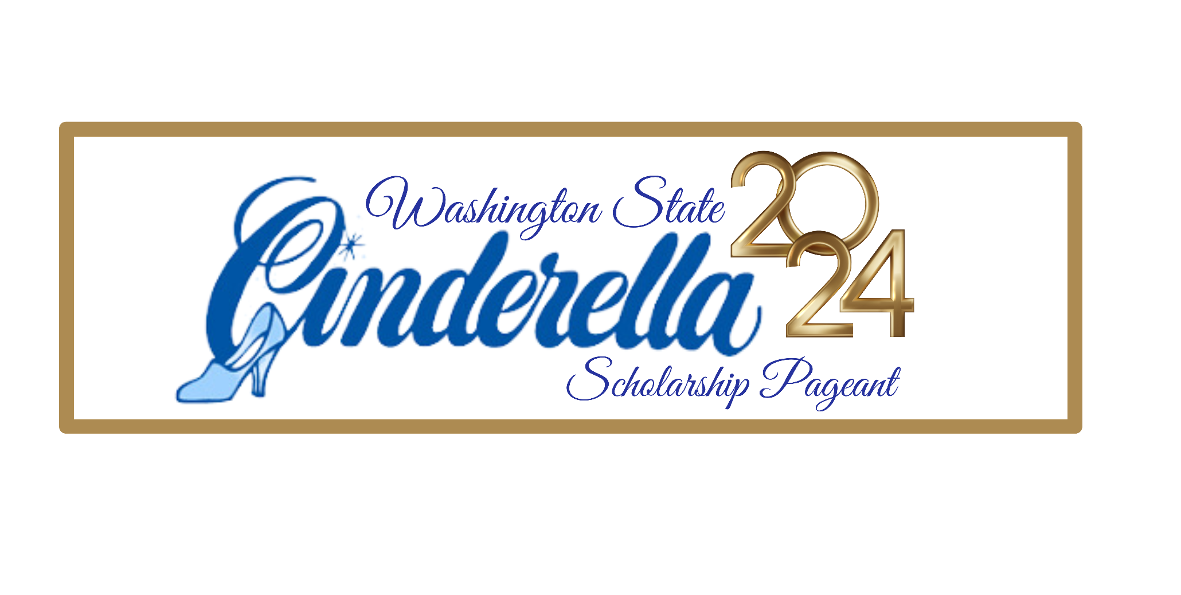

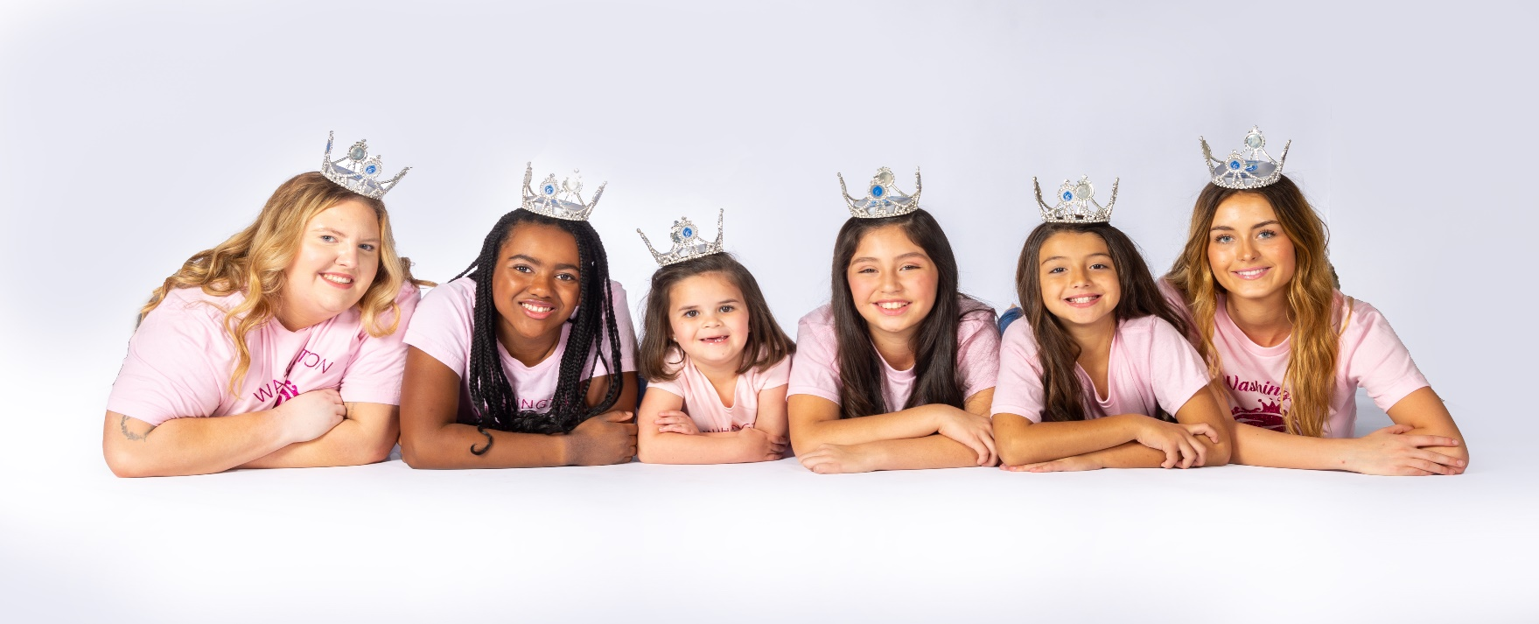
MARCH 22, 23, 24TH 2024

WHAT THIS HANDBOOK CONTAINS
This participant Handbook is an important part of your State Pageant Paperwork. You will find the Rules and Regulations regarding your State Pageant Competition as well as information on prizes and awards. Please make every effort to read these pages, as they will answer many of the questions you might have about the pageant.
HIGH QUALITY PAGEANTRY and low fees! We take great pride in the exceptional program we put on for all of the contestants and their families.
STATE REGISTRATION & LOCATION
In order to reserve your entry in the State pageant you must register online at www.wacinderella.com along with your $100 non-refundable Registration fee.
2024 PAGEANT LOCATION: Waller Road Grange
2708 64th St. E., Tacoma, WA.

THERE IS NO HOST HOTEL, CONTESTANTS CAN CHOOSE WHERE THEY WANT TO STAY OR TRAVEL BACK AND FORTH TO THE HOST VENUE. (THERE WILL BE AN AREA FOR CONTESTANTS TO CHANGE IN AT OUR HOST VENUE)

Just a few hotels in the area of Tacoma:
Comfort Inn & Suites Downtown Tacoma * Holiday Inn Express & Suites Hotel * Comfort Inn & Suites Downtown Tacoma * (please note that there are several more in a 15-mile radius from our venue)

REQUIRED COMPETITION CATEGORIES
CINDERELLA BABIES (Infant, Baby & Tiny Tot):
Infant 0-11 months Baby 12-23 months Tiny Tot 24-35 months
Photogenic, Baby Playtime, Party/Formal Wear Modeling & Casual Wear Modeling with Introduction (Intro is done by the parent in the Infant and Baby age divisions, Tiny Tots have the option to say their introduction by themselves if they prefer but its not necessary.
CINDERELLA GIRLS: (Tot, Miniature Miss, Miss, Teen & Woman):
Tot 3-6 years Miniature Miss 7-9 years Miss 10-12 years Teen 13-17 years Woman 18-29 years
Photogenic, Interview, Party/Formal Wear Modeling, Casual Wear Modeling with Introduction & Tot Personality/Talent.
Orientation and Registration
State Orientation is mandatory for all contestants and parents and will done at the Western Banquet. Contestants typically dress to impress! Contestants Group photos will be taken by our state photographer Lori Gush!
What happens at registration? Contestants can wear their crowns and sashes from previously won preliminary competitions at Registration. Contestants and parents check their EMCEE cards, get their contestant number, schedule, pick up their state t-shirt, turn in their official headshots, turn in souvenirs for the gift bags, turn in the gift for the gift exchange, go see Mr. Dan for music turn in at the sound booth, pay for tickets to parties and admission tickets for family members, get the state program book, contestants pick up their state gift bags, meet the royalty and the autograph table and can pay for official stage photos by our state photographer Lori Gush!

CONDUCT
At Cinderella Pageants the emphasis is placed on participants and adults displaying good manners and grooming, listening to instructions, adjusting to conditions, maintaining discipline and dependability, and above all, always displaying excellent sportsmanship. A parent, guest or participant who conducts themselves in an unsportsmanlike /unladylike manner (either before, during, or after an official Cinderella Pageant) will be subject to immediate dismissal from the pageant system. Such conduct by the participant will mean forfeiture of all awards and titles.
Because the Cinderella Scholarship Pageant is a youth development program and a "family affair", the following rules and regulations will be enforced throughout the event. No Alcoholic Beverages will be allowed in or around the staging area. This rule is enforced at every level of the pageant system and includes participants, parents, staff and guests viewing the event. Any violation of this rule will mean immediate disqualification from the Cinderella Program. All participants, chaperones and guests MUST observe housing rules and curfews imposed by the pageant.
SMOKING BY PARTICIPANTS IS STRICTLY PROHIBITED. Likewise, the NO SMOKING rule will be enforced in and around the staging area for the health and well-being of the participants and those who do not smoke. Smoking will be permitted only in designated areas. Participants, chaperones, and guests who cannot observe the rules of the pageant are asked not to attend.
NOTE: Disqualification from the Cinderella Pageant is a serious matter. If a participant is disqualified, she will not be eligible for a refund. Participants & Chaperones must not have a criminal record to include a Felony or any crime against children to be part of the program.
PAGEANT STANDARDS
A "standard of modesty" must be maintained throughout the pageant (includes casualwear, talent and party dress / formalwear competition and casual wear around the event). Garment removal is not allowed on stage in modeling. Props, such as tennis rackets, hats, purses, etc., are not allowed in modeling presentations, but are acceptable in talent presentations if the item is necessary for the presented talent. The prop must be USED in the routine and CANNOT be a piece of decoration or scenery.
Cosmetic dentistry is permissible. The use of cosmetics is allowed in all age brackets for stage events; however, makeup MUST be appropriate for the participant's age category. PLEASE NOTE: Tots may not wear makeup for Interview! Heavier makeup may be worn under strong stage lights. Artificial hair and false eyelashes are not allowed in the Cinderella 3-12 age divisions, unless it is the result of a medical necessity (i.e. illness, chemotherapy, etc.). Girls of African American decent can wear artificial/real hair pieces. This was approved by the owner of International Cinderella in the state directors meeting in 2022. This does not apply to talent presentations.
Please note the judges have been instructed to use discretion in determining whether a participant has violated any rules and if such artifices are immediately discernible to the judges' panel, the contestant can be disqualified.

Official State Photography & Videography
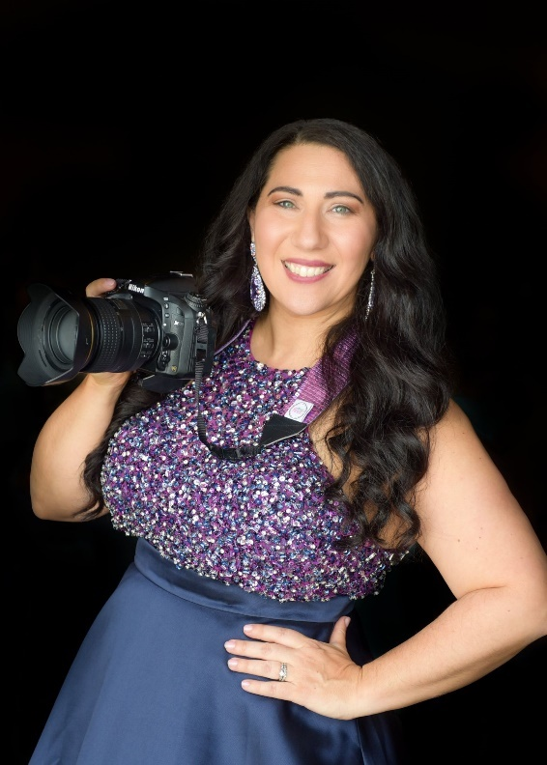
Year after year, our state photographer produces wonderful keepsakes of our Cinderella participants. Do not miss out on this opportunity! At Cinderella State Finals, only members of the press, official photographer & purchased photo passes may take photos of participants during the actual competitions. This includes all preliminary & finals competitions. NO EXCEPTIONS! Parents can use the backdrops that are around the ballroom and take personal photos only. Parents also can take photos at the parties as well but will not interfere with the state photographer. Lori will post her official link in our Facebook group or will be given by email to pay in advance. Capture the magic with our state photo package available at registration (photo packages not available after registration). State Photographer is an independent contractor and not affiliated with the WA Cinderella State Pageant Program. Photos will be available via download, no returns on packages, and all sales final. Our state photographer is Lori Gush owner of Sparkle Portraits.
All Stage Events, crowning and parties $125 Pictures of Your contestant is for all areas of competition – Opening number, Introduction, Casual Wear, Formal Wear, Talent/Tot Personality, and crowning. (party highlights are included)
SCHEDULE OF EVENTS & REGISTRATION A final pageant schedule will be available to all participants at state registration, in the contestant dressing room and online in the Facebook group.
PROGRAM BOOK
Please email Program Book Photo (Color or Black/White, Vertical Head Shot Photo & No Crown/Banners), Participant Name, Division & up to (4) Sponsors to wacinderella@gmail.com by March 16, 2024, deadline. PLEASE note we are not responsible for typographical errors. The cost of program book is $25 and it’s in full color!

2024 Cost and extra fees: NO ENTRIES WILL BE ACCEPTED AFTER MARCH 8, 2024 NO EXCEPTIONS!
State Entry Fee $300
Deposit $100 (will take off Entry fee)
(Example: after you pay your deposit your entry is $200)
LAST DAY TO ENTER IS: MARCH 8, 2024 no exceptions! All fee’s due by March 16, 2024.

If you attended a Prelim you get $50 off.
(Optional cost) In All Color State Program books are $25 and must be paid for by MARCH 16, 2024
(Optional cost) 5 Optional events $50 for all (Overall formal wear attire, overall casual wear attire, Best Interview Attire/Best baby playtime attire, overall, Tot Personality attire/overall talent costume, best overall photo in photogenic) (PLEASE NOTE: OPTIONALS HAVE NOTHING TO DO WITH WINNING ANY STATE TITLE, THEY ARE JUDGED SEPERATLY AND ARE TROPHY AWARDS.

Friday is REGISTRATION AND TEXMEX WESTERN BANQUET and Orientation
TEXMEX Western Party $10 per person. Kids 9 and under are $10

Saturday is Talent/Tot Personality, Interview, Casual Wear and the Prince Gilbert Carnival Party.
Party Entry is $10 per person Kids 9 and under are $5

Sunday is Opening Number, Formal Wear and Crowning.

ADMISSION INFO:
Saturday Competition Day Admission is $5 per person with no party.
Sunday Grand Finals Admission is $10 per person

State Entry Fee for the contestant includes all events, all parties and meal.
Only one chaperone ticket per family accompanying contestant(s) covers Admission off all events, all parties and meal.
(Optional cost) State Photography $125 (see page 4 about photography)

SIBLING DISCOUNT
Our Cinderella Program is a “Family Affair”, where we encourage siblings to participate in state finals by not requiring a second family member to have an additional chaperone. Every child who participates will get an additional chaperone ticket. Siblings competing in the same age division will be separated in their order of appearance by taking one sister and moving her to another position in the lineup so they will not be appearing back-to-back in any phase of the pageant. (DID YOU KNOW??? This discount can be combined with your preliminary win on top of $50 off on your state fees!
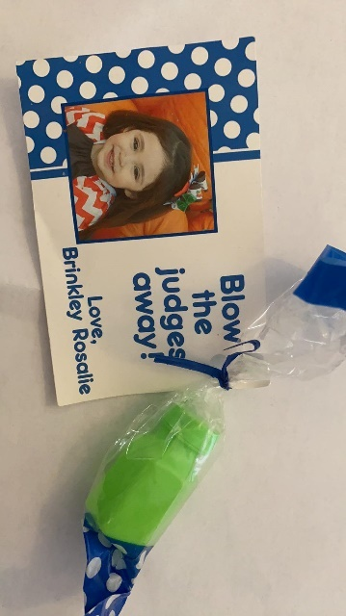
SOUVENIR GIFT AND CONTESTANT GIFT EXCHANGE
A memorable part of the Cinderella pageant is the exchanging of souvenir gifts with other participants. You will need to bring a minimum of 50 gifts for the participants in your age division, staff, judges and the reigning queens. These souvenir gifts are tokens of friendship from you and your area and may be donated to you by your city, state, Chamber of Commerce or the merchants of your area. They SHOULD NOT be expensive; however, they may not be brochures or literature of any kind. Simple, small, and thoughtful items are desired and will be treasured.
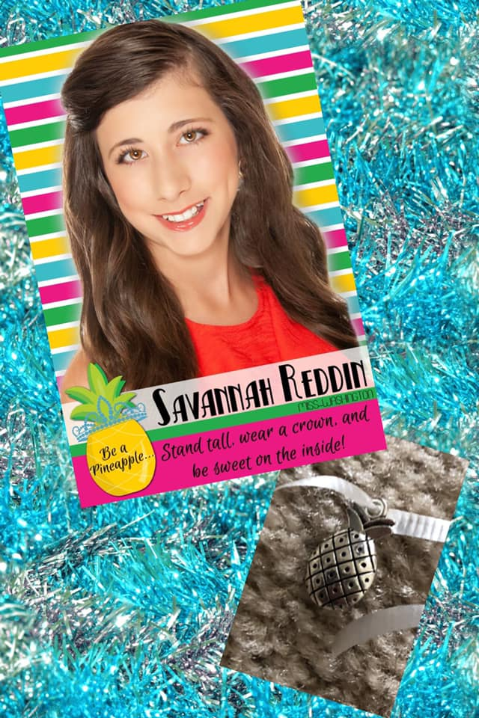
Each gift should be personalized with your name, title and best wishes from your contestant (NO ADDRESSES, PLEASE). Upon arrival your souvenirs will be turned in at registration. Gifts will be distributed by the staff prior to the special "Souvenir Party" listed on the schedule and given out at the TEXMEX WESTERN PARTY DINNER. Use your imagination in preparing your souvenir gifts. We have found that the ideas are limitless. Some of the best gifts in the past have actually been made by the participants and their families. Remember, it is not the expense of the gift that is important, but rather the thought behind the gift that really makes it meaningful. Come on and join in the fun and help make this year's souvenir gift bags the most clever and creative in our history. Your souvenir gift is NOT a scored part of the competition but is a fun special award given out to the best overall souvenir gift!
Example pic: is a charm bought in bulk off Amazon
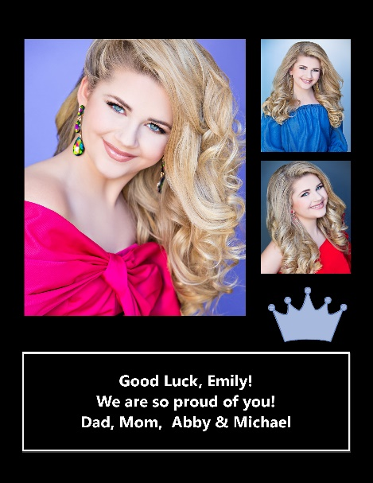
COVERGIRL AD INFO & COMMUNITY SUPPORT TITLES YOU COULD BECOME THE “CINDERELLA COVER GIRL or COMMUNITY SUPPORT TITLE HOLDER” by selling advertising pages in the official state program book. Every participant can place one or more photos in the program book on their very own advertising pages showing the different sides of their personality and their community backing.
Cover Girl Crown
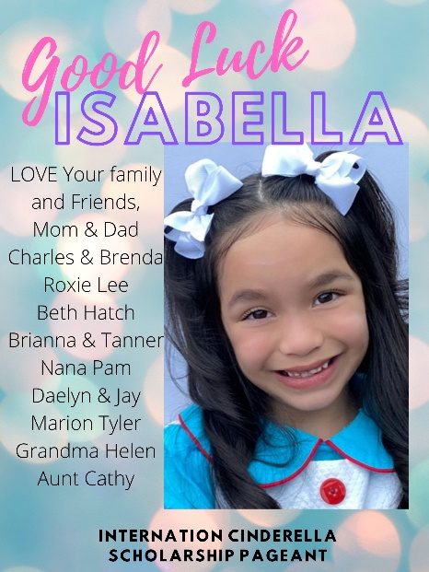
To qualify for the “Cover Girl Title” you only need one photo advertisement to be placed in the program book. A separate panel of judges will select a winner prior to the pageant. Judging is based on the participant's photogenic beauty, personality, photographic creativity, and the quality of the photograph. Participants may enter as many photos as they desire so long as they appear in additional advertising that they have purchased in the souvenir program book. One winning photograph in the entire pageant will appear on the special Cover Girl page in the front section of the program book. In addition to the distinct honor of appearing as the Cover Girl in the state program book, winner receives an official Cinderella crown and sash. Example to the left is Cover Girl winner from 2021.
Community Support Crown
These winners, along with the other contestants who are also vying for the Cinderella Cover Girl title, will also be eligible to win the Community Support Crown is for the participant that sells the most advertising pages. Get involved in your community and have your favorite businesses sponsor your Washington State Finals fees. If you have been awarded any title at a prelim, put your tiara and banner on and go to various business in your area. Be sure to tell them that the cost of an ad is tax deductible as an advertising expense. This award is designed to give special recognition to participants whose photos appear on additional advertising pages. The Community Support Title winner will also receive an official Cinderella Crown and Sash.
Ad Scholarships: Are available to use towards Washington State Pageant Fees. Only Full page Ads are accepted. AD pages cost $50 each and a credit of 50% of sales will be the Scholarship and applied to the participant’s state account. (Only one participant featured per ad there is NO AD SHARING) In other words… you sell a $50 Ad page you get $25 back!
AD Due Date: All Program Book Sponsor Ads are due 4/15/2023 (email to wacinderella@gmail.com and in the title line: AD Contestants Name and Age Division).
PARTIES
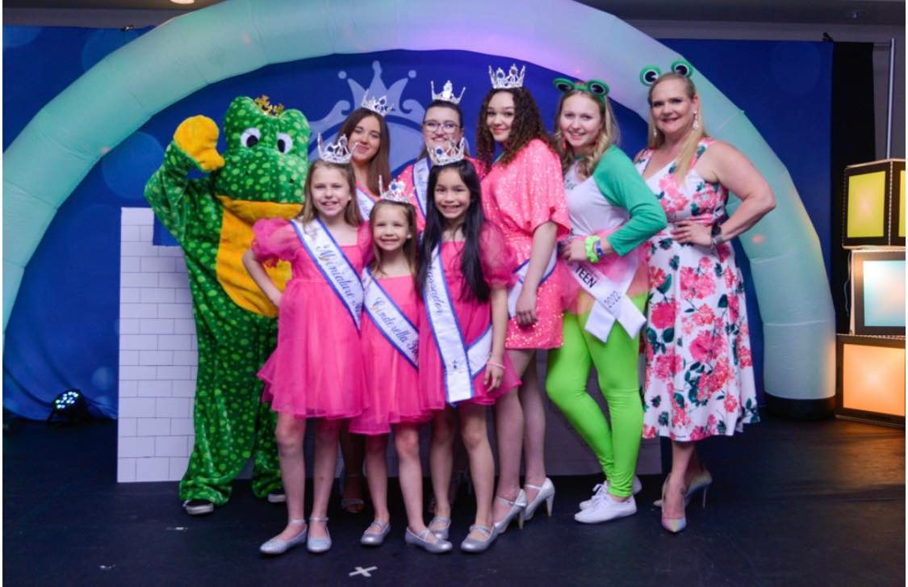
It is important that participants and chaperones attend all official functions and parties. Judges are allowed to attend these events and are looking for how participants interact with each other in a social setting. Proper attire is listed for participants for each of these events. Extra tickets will be sold at the door.
Prince Gilbert Carnival Party:
Two tickets are Included for one participant and one chaperone at registration. Extra tickets can be purchased separately for Guests as part of Ticket Package. Tickets are $10 each. Prince Gilbert is a highlight of the day and the theme is CARNIVAL! Everyone will have the opportunity to meet and mingle with he state pageant staff, special guests and reigning Cinderella State Royalty and most importantly play lots of carnival games. Meet Cinderella’s own Prince Charming….His Royal Majesty, Prince Gilbert! He has been turned into a Frog so what will become of him on this magical day?
Party Attire: Carnival is our theme and sky is the limit on what you want to wear! Special awards are given out for the best Prince Gilbert Carnival attire in each division.
THE SPIRIT OF CINDERELLA STICKS
This is for all the contestants! A very fun award to be handed out at this year’s state pageant. Having the Spirit of Cinderella and just having fun! On finals day whoever was handed a Spirit Stick will be called to the stage to receive the OVERALL SPIRIT OF CINDERELLA AWARD!

TEXMEX Western Party and dinner:
TEXMEX WELCOME PARTY!!! One participant and one chaperone are included with your registration. If your have 2 or more contestants only one parent ticket is given at registration because this is a catered event extra tickets can be purchased separately for Guests as part of Ticket Package. Meal tickets are $10 adults and $10 kids. Bring your dancing cowboy boots on for rip roaring good time at this party!
Party Attire: Western wear/Fiesta Wear
MODELING PROCEDURE

The official CINDERELLA MODELING MUSIC will be used at the state finals for all Casualwear and Party dress/Formalwear modeling competitions. The music is precisely timed so that each participant has approximately the same amount of time on stage. The music contains electronic tones, rhythmic voids, and chimes that signal the start, stops, turns, and finish of the modeling presentation. Participants are encouraged to practice with the official modeling music available at www.wacinderella.com before attending the pageant. To include Casualwear & Partywear/Formalwear selections with all the electronic tones and signals. Also, included “collective judging” segment with entrance music, timed quarter turns, and exit music (Infant, Baby & Tiny Tot Divisions face forward/do not turn). Also available is the instruction sheet on “How to Model” at an official Cinderella Pageant. The music contains professionally produced songs recorded in stereo with a full orchestra. Every participant will feel “at home’ on the Cinderella stage with the music she has practiced to at home.

Your grooming, manners, and interaction with other contestants is important at all times. Your pageant weekend wardrobe (other than presentation garments) should be casual but neat. DO NOT overdress for informal occasions. HAVE FUN!

SELECTING YOUR WARDROBE
(examples are on www.wacinderella.com) Cinderella stresses “real clothes on real people”, therefore the wardrobe that you select should reflect current trends in clothing for your particular age group. Naturally, good taste and a sense of modesty should be a part of selecting the wardrobe.

In other words, your party dress (formal wear), should be something that a person your age would ACTUALLY WEAR to a formal event.... NOT a dress that could only be worn to a pageant (the same thing applies to Interview and Casualwear garments). Garments chosen should be in good taste and appropriate for the participant’s age.

Cinderella Pageants were not designed to be a "clothes show" and your pageant wardrobe should be kept simple and appropriate for your age group. The judges will be judging the participants and NOT their wardrobes. Flaunting an OVERLY EXPENSIVE WARDROBE is often detrimental to the participant's image as a wholesome, unaffected, and “natural” girl. The judges often see the participants between judging sessions, so having a neat appearance always is important. Every participant will have garments in her own wardrobe that are appropriate for the International Pageant (having all new clothes is not necessary). Shorts and Cinderella T-shirts are an excellent choice for our casual parties.
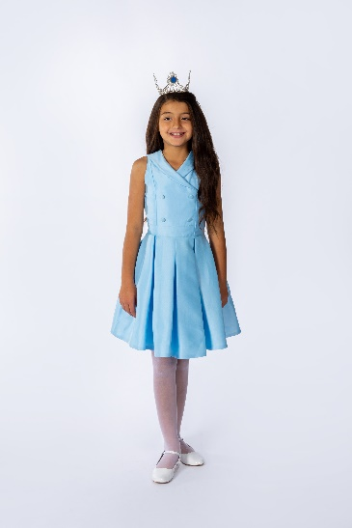
Interview with Judges
Tot, Miniature Miss and Miss Age divisions: A casual garment of your choice. The garment might be a casual skirt and blouse, a casual dress or pants and blouse. Teen & Woman Age Divisions: A tailored business suit or dress is appropriate. Prince Charming ages 7-10 years: A nice Easter type/church outfit. Example to the right is Tot Interview.
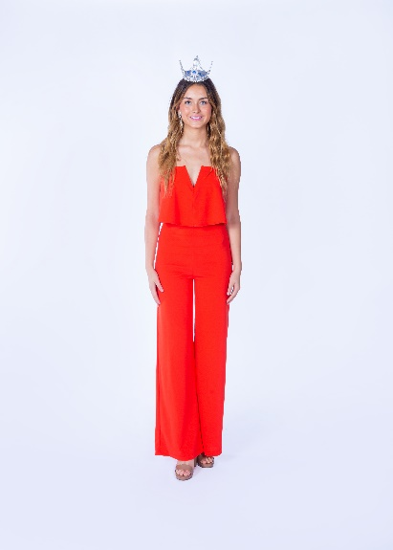
Casualwear Modeling
All age divisions: The garment can be “dressy casual” and may include pants, blouse, casual dress, and casual jackets. (No purses or handbags.)
Example to the left is Teen Casual Wear.
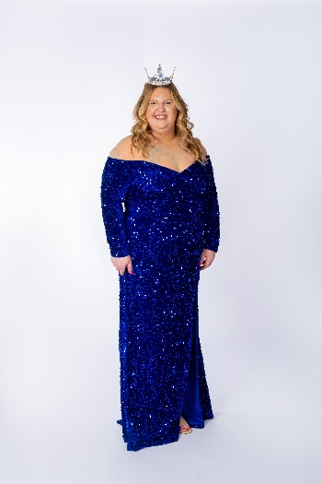
Partywear/Formalwear Modeling
Tot, Miniature Miss and Miss Age divisions: The hemline may be above or below the knee but may NOT be formal (full) length. Some examples might be an Easter Sunday or First Communion dress for the youngest division. For older divisions, a dress that she might wear to a family wedding would be appropriate. Any color is acceptable. Your grooming, manners, and interaction with other contestants is important at all times. Your pageant weekend wardrobe (other than presentation garments) should be casual but neat. DO NOT overdress for informal occasions. HAVE FUN! 12 Teen & Woman Age divisions: The hemline must be formal (full) length. Additionally, it should be age appropriate. Teens should not look like the older participants in the, Woman Division. Example to the right is Miss Formal Wear.

Tot Personality
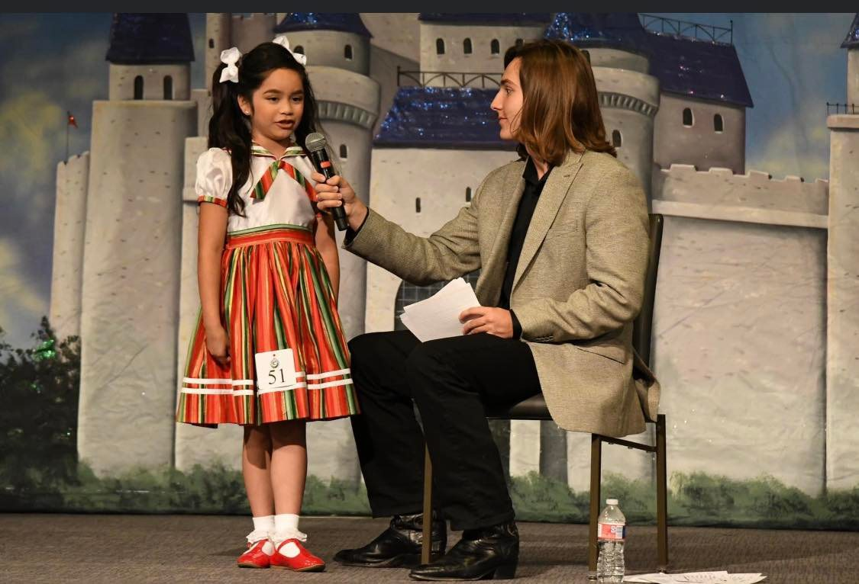
The garment can be any garment of your choice. However, it should be stylish, age appropriate and comfortable to sit in. Also, it should enhance the personality of the child.

WHAT IS TOT PERSONALITY
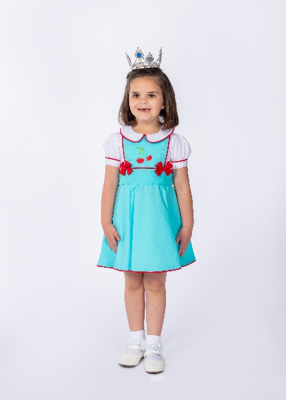
Instead of performing a talent, the Cinderella Tot participants ages 3-6 years compete in an onstage interview. During the onstage interview, the participant will be required to make a personal statement about herself giving her name, age, and hometown. The master-of-ceremonies will then ask her a few questions relating to the Information on her biographical sketch. The onstage interview is designed to encourage participants to develop their skills in communication and personality projection. This is not an intelligence test, but rather, to display the communication skills and the personality of the Cinderella Tot being Interviewed. The participant with the best onstage interview is named the International Tot Personality Winner.
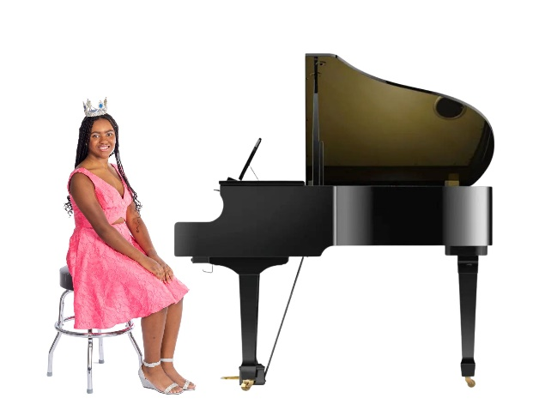
Talent Competition Miniature Miss, Miss, Teen & Woman Age divisions: The garment chosen should be appropriate for the talent being performed. It may be a costume. As always, it should be stylish but age appropriate. What kinds of talent are not allowed at Cinderella on a state and national level are:

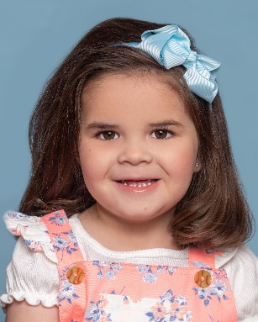
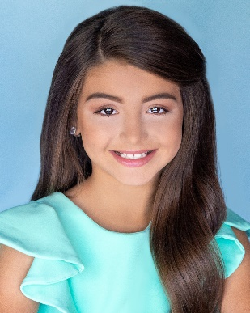
PHOTOGENIC GIRL

All participants compete for the "Photogenic Girl" award for their age division. The photo may not be larger than an 8x10 & turned in at registration. You may also use this photo for the Program Book’s “Photo Roster” section as well as any Additional Advertising. However, alternate photos may be used for the Photo Roster as well as Advertising Pages. Please note that the submitted photo becomes the property of the Cinderella Scholarship Program and will be used by the judge’s panel for reference and judging and may be used for publicity before, during and after the pageant. Don’t write directly on the photo put a label on the back so you don’t damage the photo or the ink doesn’t blead through the photo. These photos will in no way affect the adjudication for the Overall, Talent or Beauty titles; however, the photo should be as attractive as possible. The Photogenic Girl competition is an important part of the Cinderella International Finals. It was designed to give recognition to those young ladies with special photographic qualities and has become a valuable asset to those seeking careers in the modeling industry.

The Photogenic Girl in each age division will be selected on the following basis: Photographic beauty, captured personality or mood, composition, and the technical quality of the photograph. Photographs should not include trophies, crowns or banners won at a previous pageant. The participant should take care that the photo is recent and that it closely resembles the participant as she will look during her State Pageant competition (i.e. age, hair style/color, etc) Remember the judges use these photos for the Photogenic Competition and as a reference tool during their deliberations. While Cinderella makes every effort to return these photos before the end of the pageant, the pageant cannot be held responsible for any photo that is lost or damaged.
MISS CONGENALITY
Mini Miss, Miss, Teen and Woman Contestants only: One of the most important awards given to one contestant in the Cinderella Mini Miss to Woman division is the Congeniality Award. The Congeniality Winner is selected by the other contestants as the friendliest and most cooperative participant during pageant week. Voting will take place Sunday Morning.
CINDERELLA BEAUTY JUDGING CRITERIA
The Cinderella Beauty is an especially important part of the pageant system. The Cinderella Beauty winners and alternates are selected from their ranking in Interview, Party dress/Formalwear and Casualwear. The Cinderella Beauty Title is about more than physical “beauty". Judges are asked to consider the "total contestant" and not just physical appearance. Inner beauty, grooming, poise, stage presence and self-confidence are important parts of the judging criteria to select a Cinderella Beauty Winner. Garment choice also plays a role in the score.
As mentioned throughout this handbook, age appropriate attire is required and expected. The garment selected should also be visually appealing in cut, color, and style. Also, the garment selected should be able to be confidently worn to a “real life” event. The participant should ask herself the following, “Is this something I can wear to a place other than a pageant”. If the answer is “Yes”, then it should be appropriate for Cinderella.
JUDGING
The adjudication at the Cinderella State Finals is always of the highest quality with an experienced panel of judges using a point and consultation system. The judges' decision is always final, and no posting of ballots or rating is permitted. We do not provide score sheets or comments. Please do not ask the Judges for personal comments after the pageant as they are NOT ALLOWED TO GIVE PERSONAL CRITIQUES.
All participants compete in Interview, Party dress (formalwear for Cinderella Teen and Cinderella Woman participants) and Casualwear... thus making them eligible for all Cinderella Beauty awards. Those participants who also compete in talent (onstage interview for the 3-6 age division) will also be eligible for the Overall Titles and Talent Awards (Tot Personality Award for the 3-6 age division). All participants will introduce themselves at the microphone during their Casualwear presentation. The judges will NOT be searching for a "miniature adult" in the children's divisions. Likewise, the judges will NOT be looking for a "college-age" prototype in the teen division.
The Cinderella Scholarship Program is looking for a natural, wholesome type of winner to carry the official Cinderella State Title. The State Talent Winner, Tot Personality Winner and Beauty winners will be selected from the preliminary rounds of competition and do not have to be one of the top Ten Semi-finalists. The judges will select a Top Five in each age division (If there is 6+contestants in each of the Tot-Teen Divisions) to re-compete at State Finals for the selection of the State Overall Winners. If there are less than three participants in an age division, the state office reserves the right to cancel or combine the division.
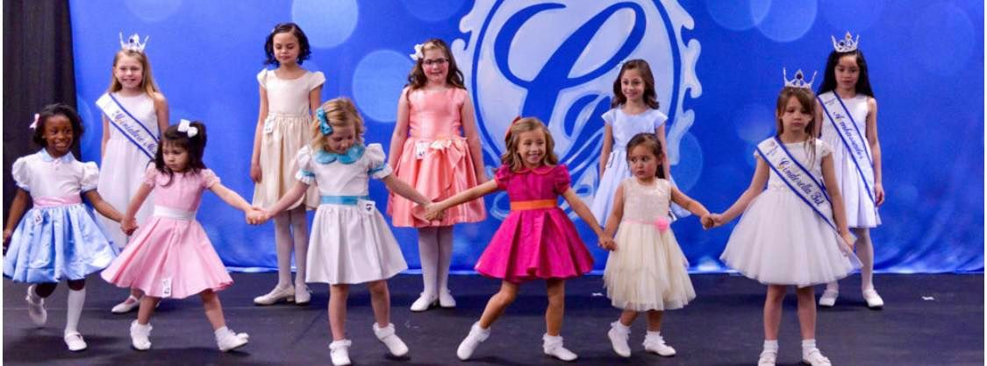
PRODUCTION NUMBER
Please wear your state shirt & contestant number (received at registration) and jeans or jean shorts! We will be taking photos at all our production practices. Opening number is easy and fun for all please do not stress over the opening number.

TALENT

Email Talent Music to: wacinderella@gmail.com Subject: Talent Music, Name & Division (due by March 16, 2024) Please bring a Backup CD, thumb drive or have music downloaded onto your phone with your USB cable to be held in reserve in case something happens to the original.

The judges will consider the quality of recordings in selecting the finalists. A “stop” in the music for dialogue, etc., will NOT be allowed; however, dialogue may be timed to a continuous track. Music should be edited to stop at the end of the talent presentation. (MUST BE IN MP3 FORMAT) SPECIAL NOTE: TALENT PRESENTATIONS MUST NOT EXCEED 2:30 MINUTES IN LENGTH. Recommended 2-minute time limit as overtime talents maybe disqualified or scored down at the judge’s discretion.
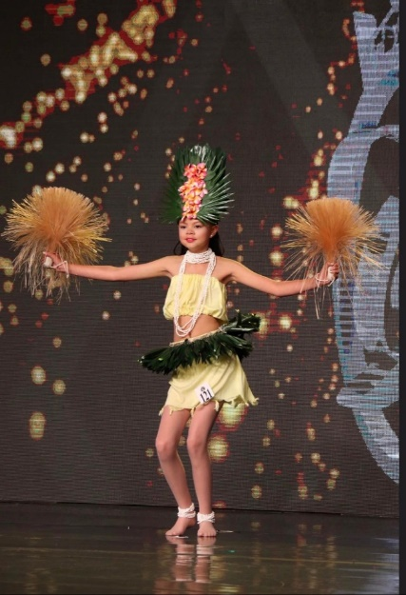
Individual talent rehearsals will NOT be held during the pageant. All talent presentations which include a singing or speaking part MUST use a microphone. The State Pageant will provide microphones (wireless handheld/stand or headset). A pre-taped accompaniment is suggested.

All props must be small enough to be carried onto the stage by no more than one (1) person. Individual scenery will not be allowed; however, a “working prop” may be used if essential to the performance.

Any equipment, other than sound equipment and microphones will be the sole responsibility of the contestant. (State venue will NOT have a piano available). Due to building regulations, the use of acrobatic equipment with hanging items such as silks and hoops, fire or knives is strictly prohibited. Acrobatic mats are limited to one (1) regulation size mat.

The pageant assumes no responsibility for loss or damage to props during the event. If a prop is used, the chaperone or talent teacher must accompany the participant backstage before the talent act to supervise the placement of the prop. Parents can be backstage if there are props your child needs help with only.

Talent costumes or presentations of a suggestive nature will mean automatic disqualification from competition. Discretion should be used in selecting talent material that is too mature or “adult” for the participant’s age division. Garment removal is not allowed. Crop tops are acceptable if they are in good taste. Talent will be judged on: 1) Appearance; 2) Composition of Routine; 3) Variety & Difficulty; 4) Execution; 5) Presentation.

LIMITATIONS OF RESPONSIBILITY
The pageant will NOT assume responsibility for lost articles or personal property and is NOT responsible for accidents, mishaps, or the personal care of the participants. This is the sole res possibility of the chaperone. Although the pageants official insurance coverage does cover medical expense for accidents (NOT ILLNESS) during the pageant, the pageant does not assume any liability or responsibility beyond the limitations of the Cinderella Registration & Insurance Program. Each participant’s parents or official guardian MUST sign the official liability release form, which is included on the state entry forms.
PRESS INFORMATION
The Cinderella Scholarship Pageants are newsworthy events and should garner excellent coverage from your local news media. To get the best coverage, you should alert your friends and family across the state to request information about the state pageant (before, during and after) from their local news sources. This should begin now. If the media is alerted that a local participant is representing your community at the official state pageant and they have been contacted beforehand, they should offer excellent publicity. Ask your director for a press release. Farewell photos make excellent news and mayors, governors and other public officials will usually cooperate in making a proclamation honoring their state's representative.
WHAT IS EXPECTED OF A STATE OVERALL WINNER

Winners of a State Cinderella title are to conduct themselves with the dignity of the important title they hold. Overall, Queens are required to purchase *Sash Stoning, *Sash Name Embroidery, State Wardrobe & costumes as directed by the State Office, items must be worn by all state queens and ordered by due dates. Estimated yearly cost is $200 (International clothing) this is to ensure all queens follow the same wardrobe and ordering guidelines.
Additionally, they MUST attend the International Pageant the year they win their State Title. The failure of a State Overall Winner to proceed to the International Pageant will cause automatic forfeiture of the State title and all rights thereof. If an *Overall Winner does not represent her State at the International Pageant, the first alternate will be eligible to fill the position and will assume the Overall Title. A State Overall Winner who does not attend the International Pageant, will not only forfeit her State Title, but will be banned from further Competition in the Cinderella Program on any level. (*only applies to Tot, Miniature Miss, Miss & Teen Over All Winners).
State crowned Overall winners may not participate in any other pageants unless it is a benefit pageant only that has NO state level or national level title. No national level pageants are allowed during your reign as a Cinderella State titleholder. If the state titleholder is in doubt, please message your state director for clarification. If you choose to participate in any state level or national level pageant you will forfeit your Scholarship and any remainder responsibilities that come with your state title.
Overall Queens must attend 75% of all State Appearances, attend Workshop Preliminaries, State Photo Shoot & State Finals to crown their successor in order to receive scholarship award. Cinderella Infant and Baby titles & Prince Charming titles reign ends on January 1, 2024. Queens are encouraged to attend state appearances throughout the year as royalty. In addition, they are eligible & encouraged to compete at Preliminaries & State Finals.
CROWNING ON FINALS DAY
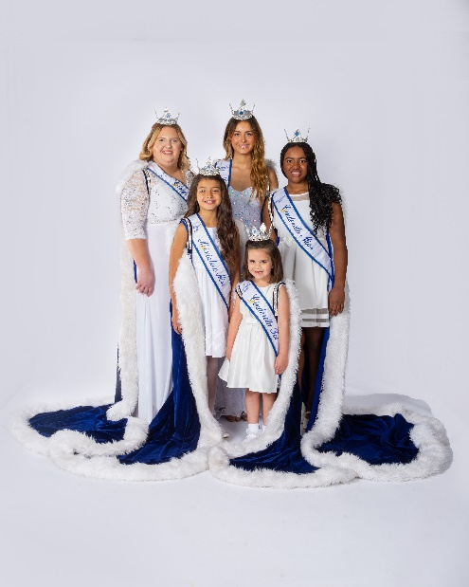
The fabulous states finals of the Cinderella Scholarship Pageant will be a “thrill of a lifetime” for every participant and certainly many people will want to share these marvelous memories. The parents, friends, relatives, and special guests of the participants are cordially invited to attend any and all of the official state pageant functions. The competition is fantastic, and we know they will enjoy seeing the state’s finest young talent and see who will be crowned the next state title holders. Dressing facilities will not be provided for the contestants on the last day of competition, parents/chaperones should have their contestant ready before checking out of the hotel. Each contestant is solely responsible for her own garments and personal articles on finals day. Please make sure that you don’t forget anything on finals day.
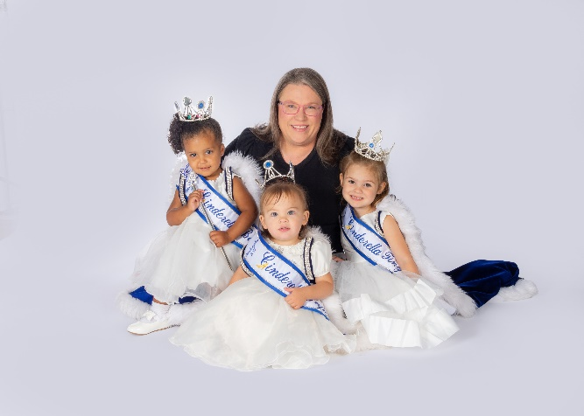
OFFICIAL ROYALTY MEETING AFTER CROWNING
Following Finals, the newly crowned Overall Queens and (1) Chaperone will be required to meet, Sign the Queen State Contract and review State & International Requirements. DID YOU KNOW? All other state winners and participants who competed at our state pageant and would like to attend the International Cinderella Pageant be sure to contact the state Director Carey Sanchez by phone or email. There are discounts for everyone to go to the international pageant to go as TEAM WASHINGTON!

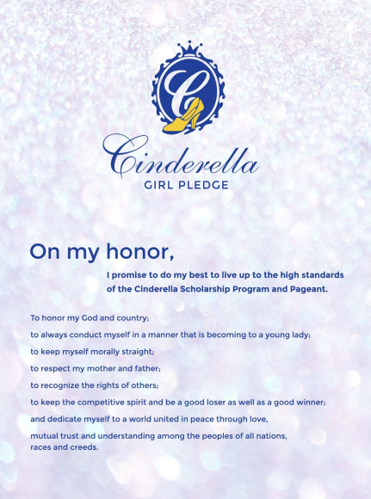
2024 Washington State Cinderella Awards

Cinderella Girls Overall Winners
Tot through Cinderella Woman Divisions
Official Cinderella Round Crown
Satin Embroidered Banner
Custom Cinderella Trophy
Use of Official WA Royalty Robe during Reign
Use of State Royalty Dress/outfit
**End of reign Scholarship Award
$275 towards International Fees
Royalty Jacket
Custom Garment Bag
State Photo Shoot
Gifts Throughout the year such as:
Scrapbook, custom Cinderella glass ornament, State rhinestone scepter and custom scepter case and more

Beauty, Talent/Personality & Photogenic
Tot through Cinderella Woman Divisions
Official Cinderella Round Crown
Satin Embroidered Banner
Custom Cinderella Trophy
$275 towards International Fees

1st, 2nd and 3rd Alternate Winners only
Official Trophy

Washington Cinderella Babies
Overall Winners
Official Cinderella Round Crown
Satin Embroidered Banner
Custom Cinderella Trophy
Use of Official WA Royalty Robe during Reign
CASH Scholarship Award
$150 towards International Fees
Royalty Jacket
Custom Garment Bag if traveling to International Cinderella
State Photo Shoot
Gifts Throughout the year such as:
Scrapbook, custom blanket, custom Cinderella glass ornament, State rhinestone scepter and custom scepter case

Washington Beauty, Best Personality & Photogenic
Official Cinderella Round Crown
Ribbon Banner
Custom Cinderella Trophy
$150 towards International Fees

Community Support Winner and Cover Girl Winner
Official Cinderella Crown
Satin Embroidered Banner

*Awards based upon 85 or more participants,
Tot through Teen, attending the 2024 Washington State Pageant
*84-65 Participants: Overall - $500.00 Award
*65-46 Participants: Overall - $350.00 Award
*45-31 Participants: Overall - $200 Award
*Below 30 Participants: Overall - $100 Award

